|  |  |  |
| --- | --- | --- |
| **http://tbn3.google.com/images?q=tbn:f78n5s10fmfqSM:http://www.geocities.com/rpusala/Indian_Emblem.jpg** | **HIGH COMMISSION OF INDIA  WELLINGTON** |  |

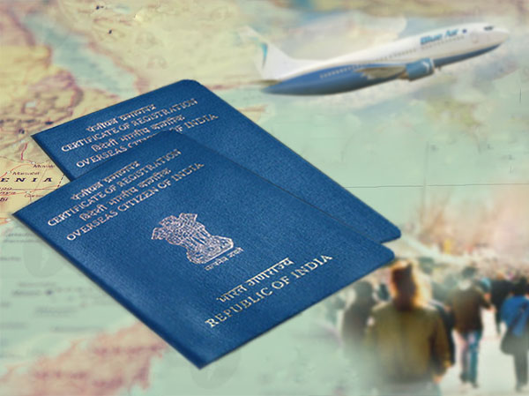

**INSTRUCTIONS FOR OCI CARDHOLDERS WHILE TRAVELLING TO INDIA**

All OCI cardholders who intend to travel to India on the strength of OCI cards bearing old passport number in it are hereby advised to **carry both the old and new passports** to avoid any problems while boarding the flight.

For any further queries in this regard, kindly send an email to [oci.wellington@mea.gov.in](mailto:oci.wellington@mea.gov.in).

****

23 March 2021